Colorado is home to over 150 licensed wineries, including a 20 cideries and 12 meaderies

(2) In any fiscal year, the board shall budget from moneys in the fund at least one-third toward promotion and marketing

Mission: ¬ To promote and develop the growth and quality of the Colorado wine industry through marketing, research and education. • Vision: ¬ Our long-term ambition is for Colorado to be recognized globally as a premier wine experience. • Strategic Priorities: ¬ Foster greater cooperation, communication and participation within the wine industry. ¬ Promote the effective relationships with beverage wholesalers, retailers, restaurants and other complementary industry partners. ¬ Elevate, develop and energize the Colorado wine brand. ¬ Provide appropriate resources and education to Colorado vineyards and wineries so that they may achieve economic viability

Can aid in addressing 3 of the 4 program area goals

1. Business & Economic Development - ➢Improve access to market and increase market knowledge.
2. Marketing ¬Move more wine

4. Research Consumer research to Identify new ways and opportunities to expand the Colorado wine industry

Marketing: You sell wine by selling the sense of place

In order to move the consumer, the critics and the media beyond the boundaries of popular perception, (see comment) they must taste the wines and experience the state.

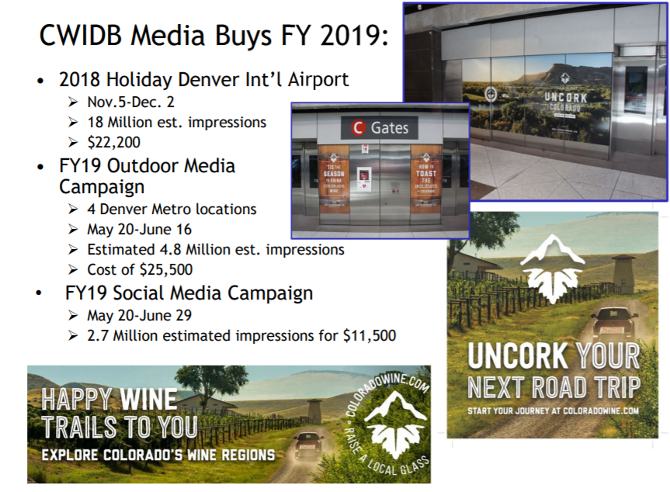

It is all about effective impressions

Awareness of Colorado wine is up slightly in 2018 (77%): • Up from 73% in 2016 among total (past mo. wine drinkers). • Conversely, 23% are not aware of CO wines.

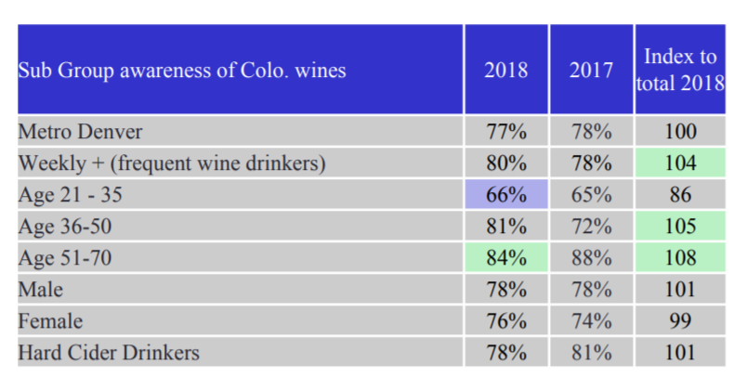

Raise awareness about Colorado wines for young Coloradoan’s

[doug.caskey@state.co.us](mailto:doug.caskey@state.co.us) Doug Caskey, exec. director CO Wine Industry Development Board

<https://coloradowine.com/wp-content/uploads/2019/02/CWIDB-Overview-distilled.pdf>

<https://coloradowine.com/wp-content/uploads/2015/04/CO-wine-prod-and-mkt-share-Sept-2015.pdf>

Lack of familiarity with Colo wines is a barrier to purchase

Among the total sample, Awareness and Trial of Colo Wines have good penetration but low purchase frequency.

Converting the “fence sitters” who may or may not buy Colo wines may be solved by generating awareness among the 25% who are un-aware of Colo wines. - Younger wine drinkers state stronger PI for Colo wines:

Neighborhood liquor stores have the highest share of purchase locations for wine and Colorado wine.

Quality perception of Colorado wine continues to be lower than other wines.

When aided, unable to find Colo wine - comes up as a barrier

Build awareness by trying different tactics - Disrupt the messaging patterns by trying new communication and awareness-building tactics as current tactics are holding awareness. Continue frequent event sampling, on and off premise Colorado wine tasting events and other tactics to build awareness and trial.

Develop retention, loyalty and re-purchase programs.

Target message tonality to younger, 21-35 more experimental wine drinkers

<https://coloradowine.com/wp-content/uploads/2019/08/CO-Wine-Consumer-Research-June-2019.pdf>

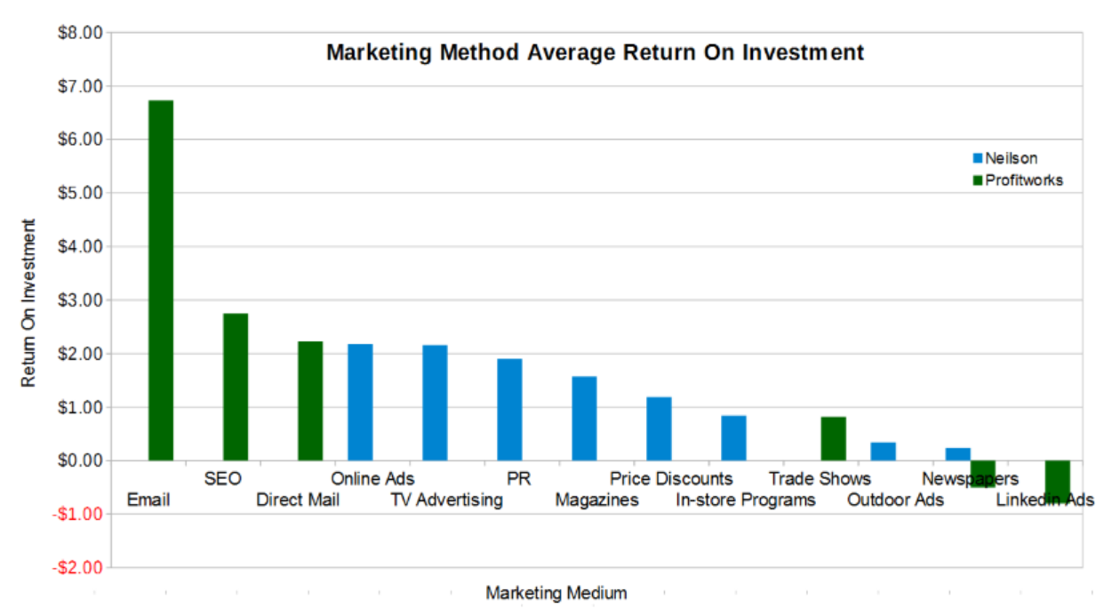

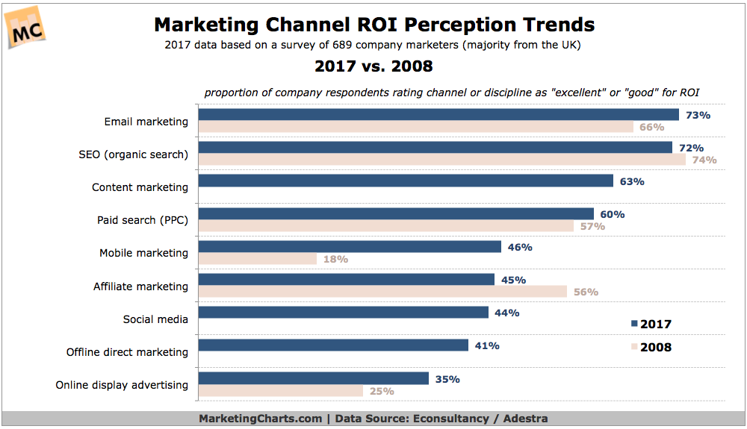

**Cultivator** Advertising and Design, Inc. - $193,000 spent in FY20

Strategic initiatives to multiple effects of existing activities and events (such as Gov’s cup)

<https://coloradowine.com/wp-content/uploads/2019/05/2020-budget-appr-20-May-2019-with-Cultivator.pdf>

Feature - Customer surveys

$2 million spent in media and customer engagement in 2018

<https://coloradowine.com/wp-content/uploads/2019/02/CO-Wine-Board-Coverage-22Feb2019.pdf>

Brand Identity. Focus. Vision

Vision : Our long-term ambition is for Colorado to be recognized globally as a premier wine experience.

Elevate, develop and energize the Colorado wine brand

Business and Economic Development Committee Goal - Improve access to market and increased market knowledge

Marketing – move more wine

They do not promote hard cider

Goals: Appeal to a younger demographic 3. Represent the range of the 150+ wineries 4. Increase quality perception 5. Drive people to where they can try Colorado Wine (tasting rooms)

Proximity to major highway